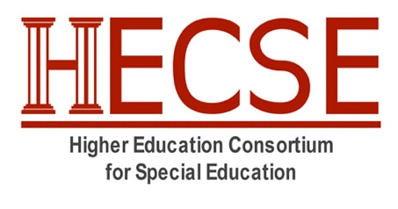
2023 HECSE Short Course on Education Policy and Politics in the Nation’s Capital: Application

Student Name: __________________________________________________________

Name of Faculty Sponsor: _________________________________________________

Institution: _____________________________________________________________

Email: _________________________________________________________________

Statement of Intent (500 words): Please attach an articulate statement indicating your reasons for wishing to participate in the 2023 HECSE Short Course. This statement is weighted heavily in the selection process and will be blinded for review. This persuasive statement should describe how the theme of the course matches your interest in participating. This can be accomplished by addressing one or more of the items below:
- Background knowledge and experiences related to key aspects of this year’s theme: Education in Crisis: The Federal Role and Other Levers for Advocacy
- Previous experiences with policy/advocacy
- Past experiences that may have sparked an interest in policy/advocacy
- Research interests related to policy/advocacy

Instructions:
- Please email the completed application form to Dr. Sarah Nagro (snagro@gmu.edu)
- Applications due on November 21st with notification of acceptance the week of November 31st
- Please contact Dr. Sarah Nagro with questions about this exciting opportunity
Scoring Criteria:
- Required statement of intent (5 Points)
- Career plans align with policy/advocacy (1 Point)
- Member university has not had a Short Course participant (1 bonus point)

Signature of Faculty Sponsor: By signing below, I certify that I support this application and will attend the 2023 HECSE Winter Summit with my student. I will ensure that my institution is a current HECSE member in good standing. I will help my student navigate attending the in-person event and missing classes and other obligations. I will discuss potential funding options available through my university with my student.

Upon acceptance, I will ensure that payment of $400 for the HECSE Short Course and Winter Summit is made, per the instructions provided in the notification letter. I also understand that my institution and/or my student is responsible for additional costs associated with participation in both the HECSE Short Course and the HECSE Winter Summit, including (a) transportation (to and from D.C.), (b) hotel, (c) meals (group meals are not covered by HECSE), and (d) ground transportation (taxi/uber to and from airport, hotel, and field visits).

Signature of Faculty Sponsor: _________________________________ Date ____________

